EXPERIMENT 7 Date:
Install Google App Engine. Create a hello world app and other simple web applications using python/java.

Aim
To install Google App Engine (GAE) and develop a Hello World application and simple web applications using Python and Java.

Requirements
- Google account
- Internet connection
- Python 3.x
- Java JDK 8 or later
- Google Cloud SDK
- Web browser

Theory
Google App Engine is a Platform as a Service (PaaS) provided by Google Cloud that allows developers to build and deploy web applications without managing servers. It supports multiple programming languages such as Python and Java and automatically handles scaling, load balancing, and application updates.
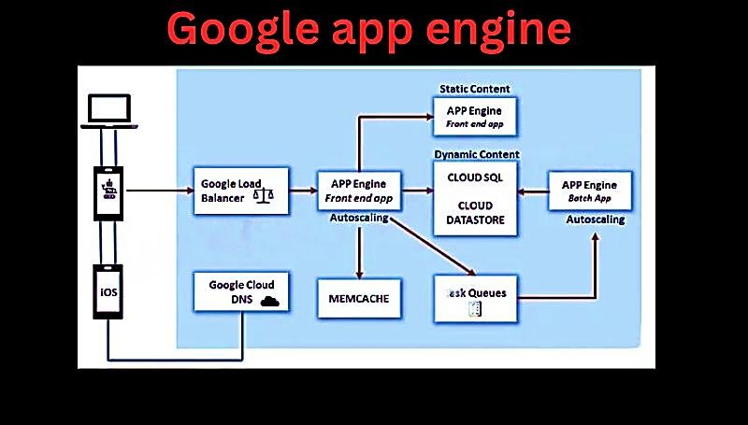

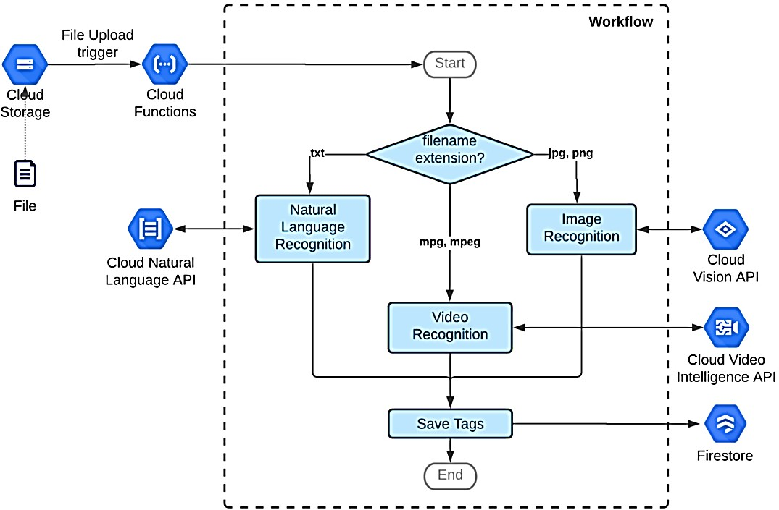
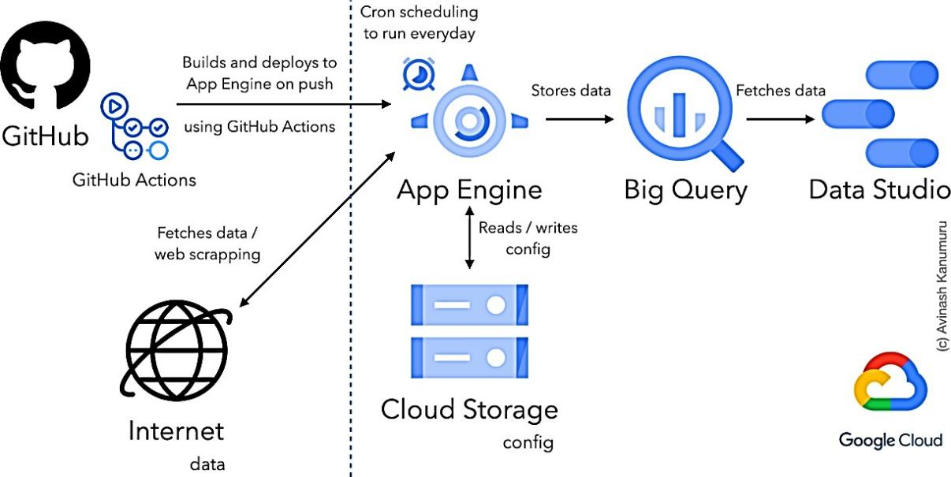

Procedure
Step 1: Install Google Cloud SDK
- Download Google Cloud SDK from: https://cloud.google.com/sdk
- Install the SDK and open the terminal (Command Prompt).
- Initialize the SDK: gcloud init
- Verify Google Cloud SDK Installation: gcloud --version
- Login using your Google account.
- Create or select a Google Cloud project: gcloud config set project even-hull-450506-t2
- Verify: gcloud config list
- Create App Engine Application: gcloud app create
- When prompted for region, Choose: asia-south1

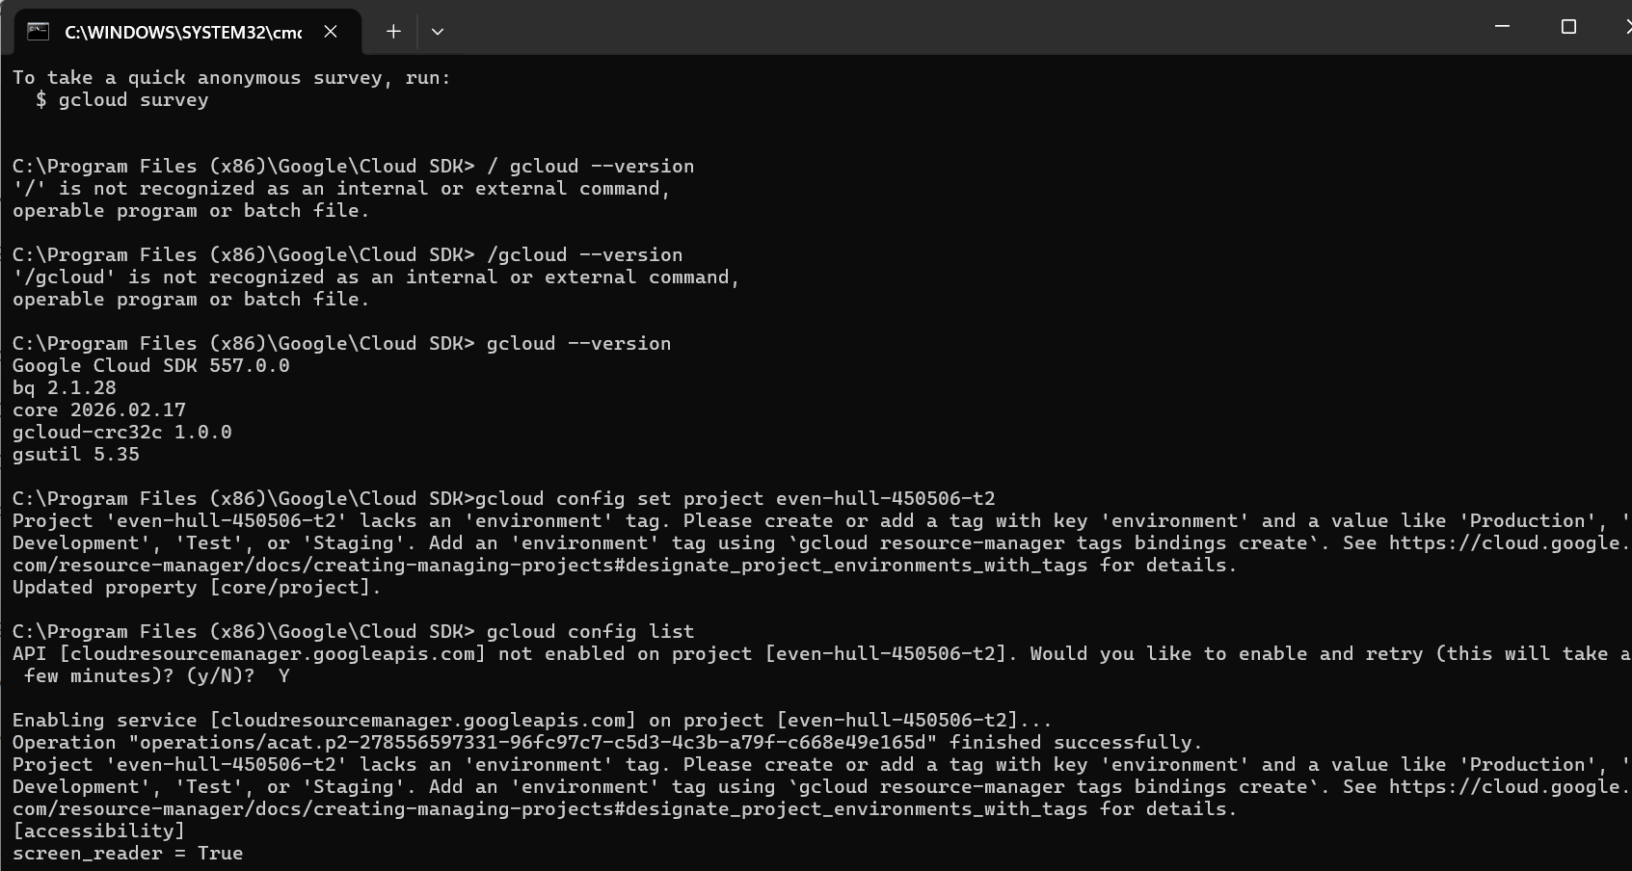

PART A: HELLO WORLD APP USING PYTHON

Step 2: Create Project Directory
mkdir hello-python cd hello-python

Step 3: Create main.py (Python Hello World Application)
from flask import Flask app = Flask( name ) @app.route('/')
def hello():
return 'Hello World from Google App Engine (Python)!' if name == ' main ':
app.run()
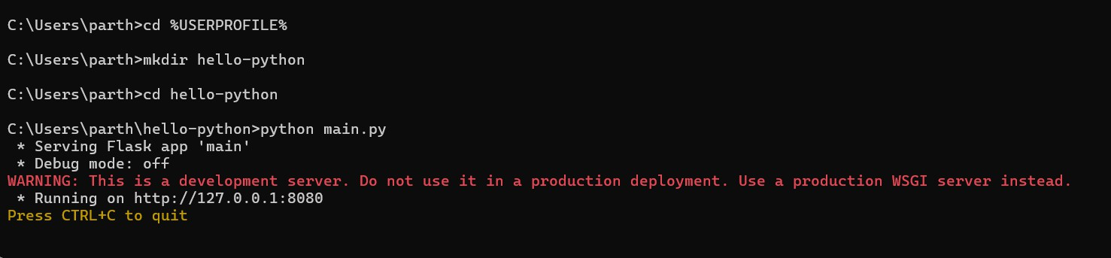

Step 4: Execution of Python Application (Local).
The Python application was executed locally using the command: python main.py

The output was viewed in the web browser using:

Open Chrome / Edge / any browser and type: http://localhost:8080

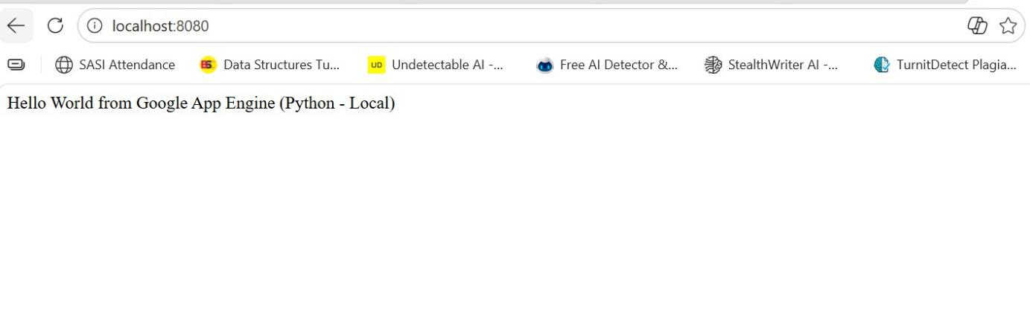

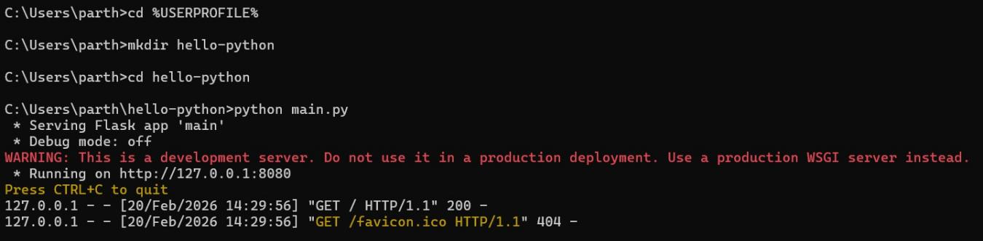

Step 5: Stop the server (after screenshot) In Command Prompt, press: CTRL + C
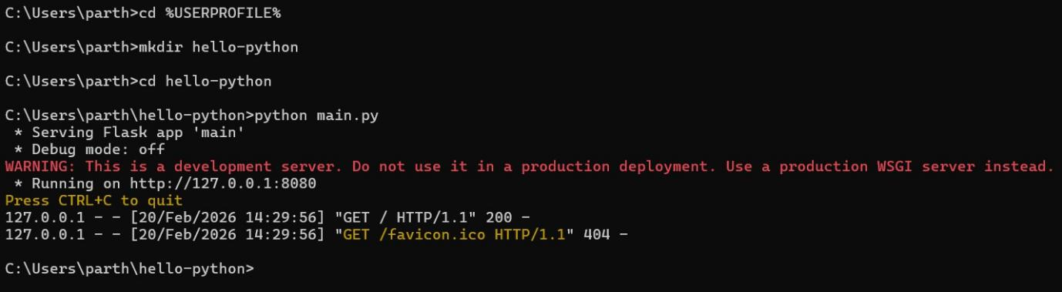

Step 6: Creation of Simple Python Web Application
The Hello World program was modified to display the current date and time.
from flask import Flask
from datetime import datetime

app = Flask( name ) @app.route('/')
def time():
return "Current Date and Time: " + str(datetime.now()) if name == ' main ':
app.run(port=8080)


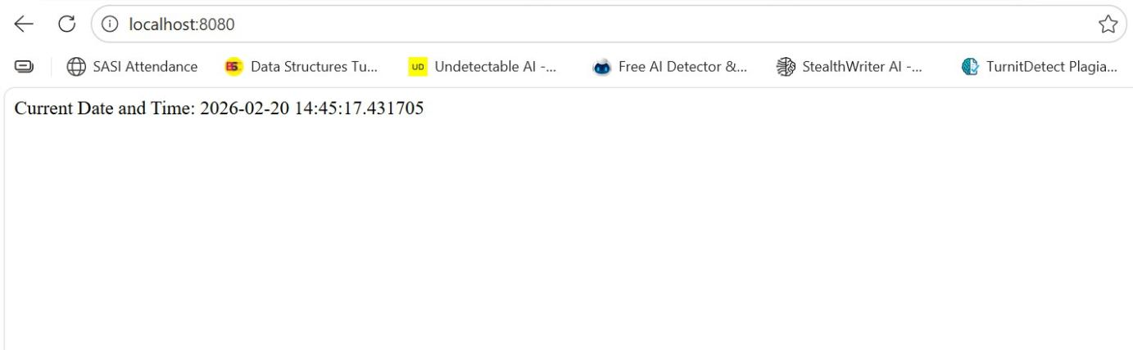

Step 6: Creation of Java Hello World Application
A simple Java servlet program was created to display a Hello World message.

File: HelloServlet.java
import java.io.IOException; import javax.servlet.http.*;

public class HelloServlet extends HttpServlet {
public void doGet(HttpServletRequest req, HttpServletResponse resp) throws IOException {
resp.setContentType("text/plain");
resp.getWriter().println("Hello World from Google App Engine (Java - Local)");
}
}

Step 7: Execution of Java Application (Local Environment)
The Java servlet program was compiled and executed using the local App Engine development setup for testing purposes.
Compile: javac HelloServlet.java

Output
- Python Hello World message displayed successfully in the browser
- Python web application displaying current date and time
- Java Hello World servlet program executed successfully

Result
Thus, Google App Engine was successfully installed and Hello World and simple web applications were created and executed using Python and Java in the local App Engine development environment.

